TASK MANAGEMENT APPLICATION

Hi , This application is developed by Yash Raghava.

It helps in managing important tasks and helps in recording self activities.

Dependencies used are –

Spring Boot Starter Web, Spring Boot Starter Validation Spring Boot Starter Data Jpa,Spring Security,MY SQL Connector,Bootstrap,JSTL.

I have used MY SQL Database to connect with Application.

I have used Docker as a container for MYSQL Database.

APPLICATION SCREENSHOT

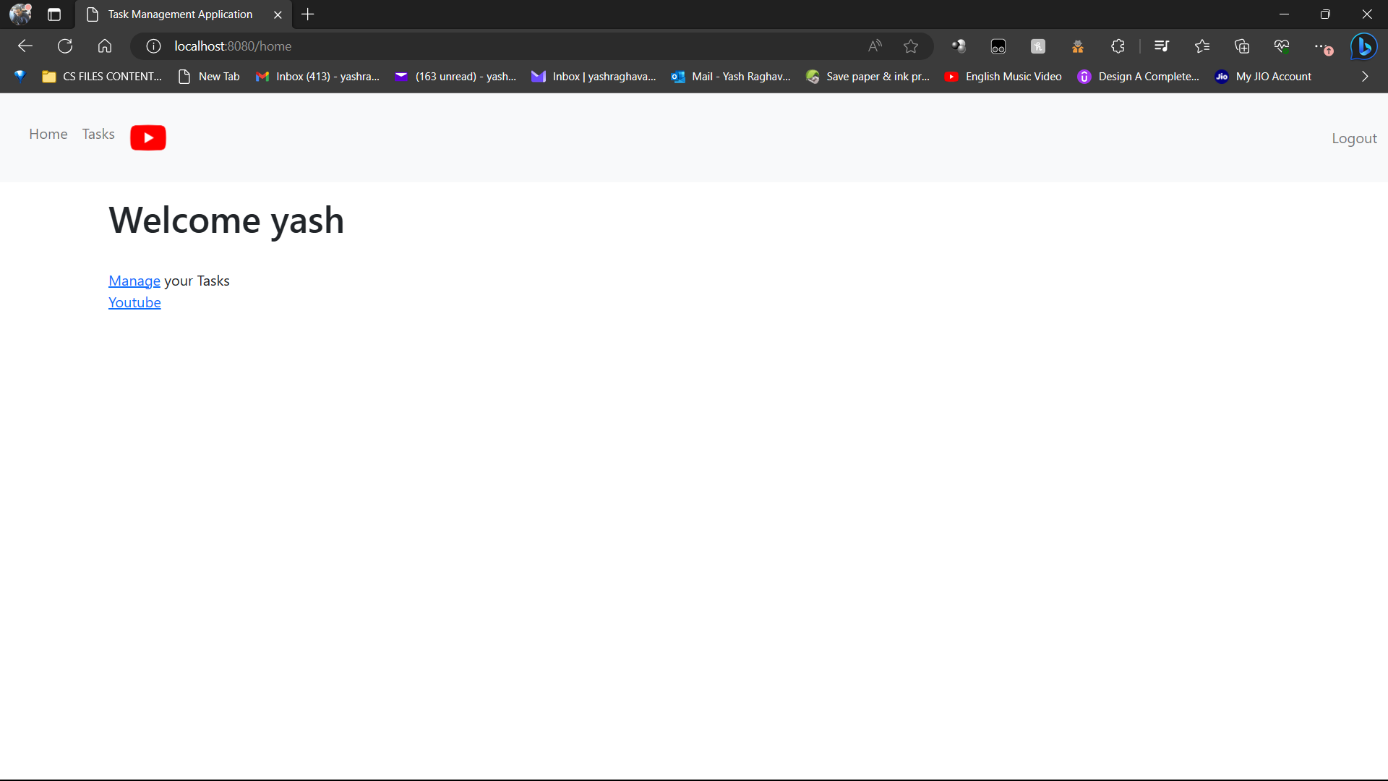

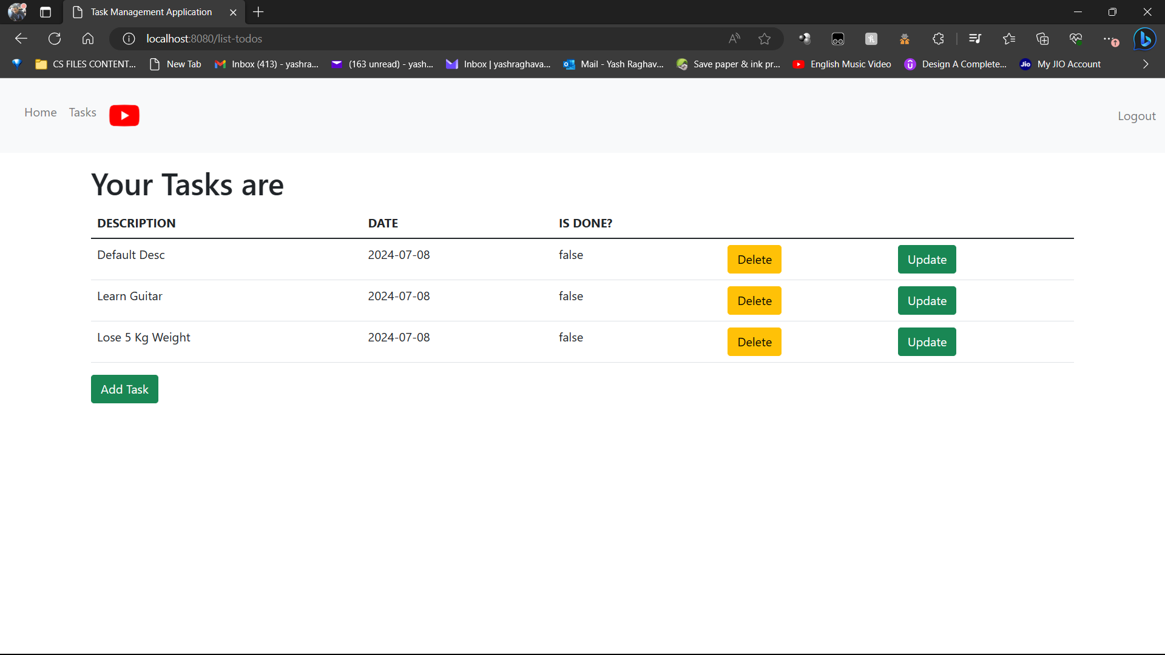

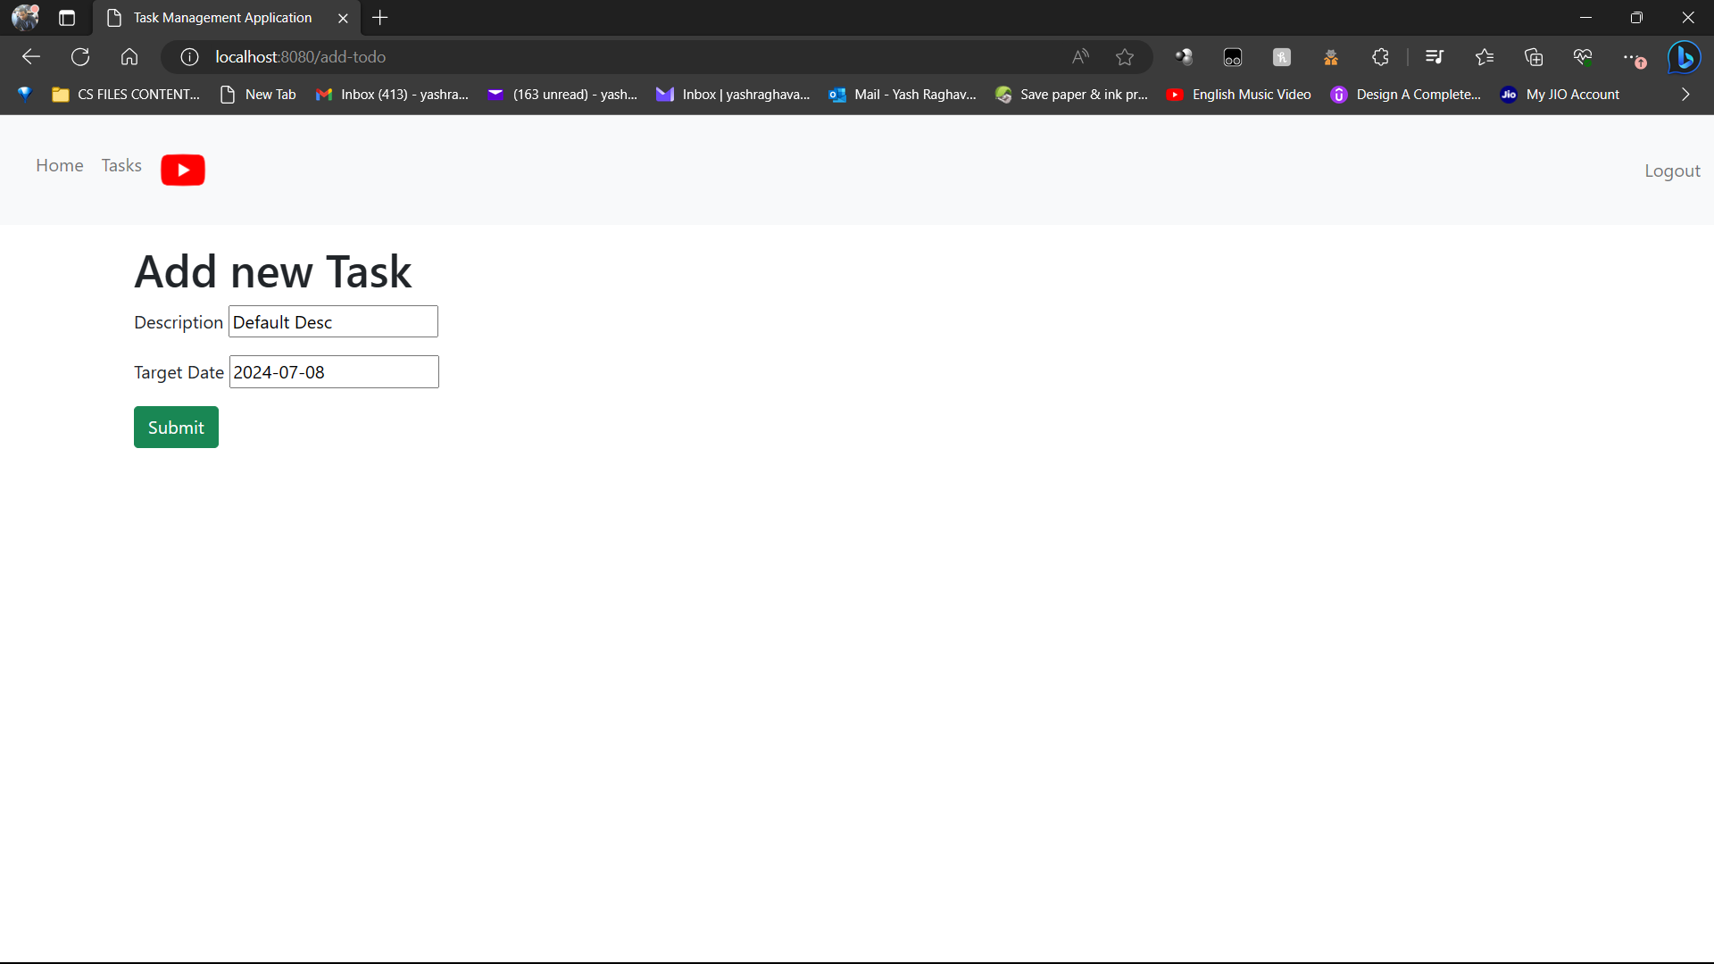

SWAGGER SCREENSHOT

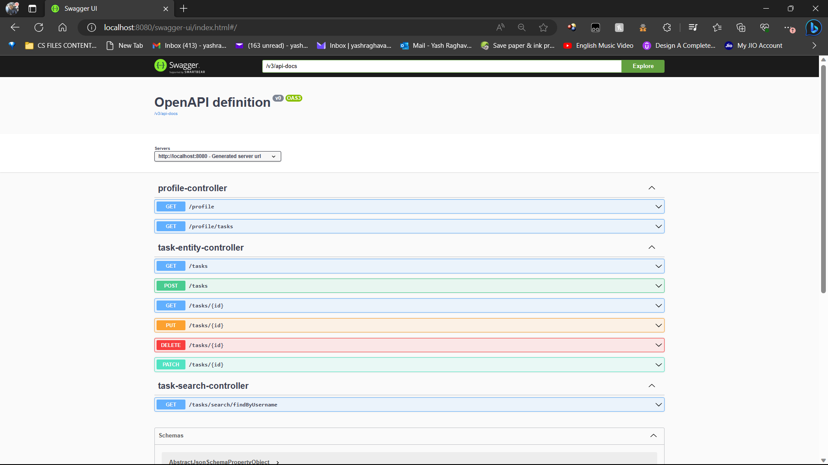

HAL EXPLORER SCREENSHOT

